Why Essential Oils...

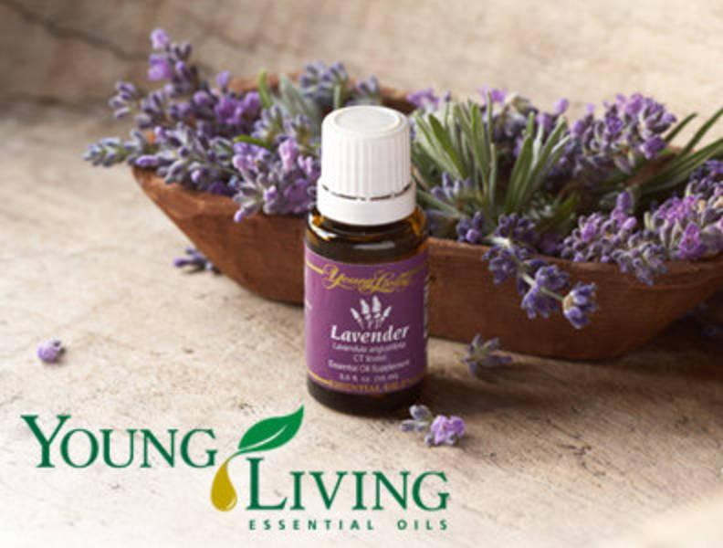
Essential oils are absorbed primarily through the respiratory system, but not only. They easily enter the bloodstream in the process of absorption through the skin, can be consumed internally (only Young Living Essential Oils) or become a valuable transportation system, antioxidant, and endless source of many valuable substances to render true miracles in our body. Of course, under one condition: that we use only very pure, natural, and high quality therapeutic essential oils, and not all sorts of junk from the store or pharmacy.

Absorption of the essential oil through the respiratory system first causes stimulation of the nasal membrane, which detects the presence of specific molecules of essential oils and sends this information directly to the brain. The brain reacts in a split second and in response to this stimulus releases either the chemical stimulant or relaxing the nervous system. Depending on the situation, the body produces various hormones - endorphins, serotonin, melatonin, dopamine, adrenaline and many more ...

The chemical compounds contained in the essential oils is getting into the lungs and has a direct physical effect on the body, which causes further therapeutic effects on the entire body. When we bathe, put a compress or are massaging, the oil is in direct contact with the skin. In the initial phase of interaction, the essential oils affects the area of contact. Then, the threpeutic molecules penetrate through the epidermis into the dermis, which is being able to enter the blood circulation. It results in further penetration of the oil into the body through the capillaries into the systemic circulation and the blood to the body. The second and third phase causes the oils to reach the farthest places of our body.

Therapeutic-grade essential oils, as opposed to all sorts of medicines and synthetic substances, do not accumulate in the human body. Their excess is quickly removed usually in a similar manner as it absorbs it, by sweating in out through the largest organ - the skin.

